Cybersecurity Risk Assessment Report 2025
NCII ENTITY NAME:

NCII NAME:

SECTOR LEAD NAME:

DATE OF RISK ASSESSMENT:

Table of Contents

Contents |  | Page Number
1 | Introduction
2 | Executive Summary
3 | Cybersecurity Risk Assessment Methodology
4 | Cyber Security Risk Description
5 | Impact & Likelihood
6 | Risk Prioritisation & Risk Treatment
7 | Document Approval

1 Introduction
The Introduction set the context of the assessment. It explains why the assessment is conducted, the scope, the objectives, and references to applicable laws, directives, and standards.

Example :
This report has been prepared to document the results of the cybersecurity risk assessment conducted in accordance with the Cyber Security Act 2024, Regulation and Chief Executive Directive No. 5 on Information Security Risk Assessment. The purpose of this assessment is to identify, evaluate, and prioritise risks that may impact the confidentiality, integrity, and availability of the NCII..
The assessment was carried out based on recognized standards and frameworks, including ISO/IEC 27005, NIST SP 800-30, and other relevant national guidelines. It aims to support informed decision-making regarding risk treatment, resource allocation, and compliance with national cybersecurity requirements.
The scope of this assessment covers [define the scope – e.g., specific system boundaries, assets, processes, or departments]. The assessment methodology includes risk identification, risk analysis, and risk evaluation, followed by recommendations for appropriate risk treatment.

2. Executive Summary
The Executive Summary should give high-level management a quick overview of the key findings without going into technical detail. It highlights risk posture, critical risks, and recommended actions.

Example :
The cybersecurity risk assessment has identified and analysed potential threats, vulnerabilities, and impacts to [system/process/service]. The results indicate that the organization is exposed to several risks that could significantly affect its operations, reputation, and compliance obligations if not effectively managed.
Key observations include:
- Identification of [X] high risks, [Y] medium risks, and [Z] low risks.
- High-risk areas are primarily related to [e.g., inadequate access controls, unpatched systems, weak third-party dependencies].
The recommended actions include implementing enhanced technical controls, strengthening governance and monitoring, and adopting a structured risk treatment plan. These measures are essential to align with regulatory requirements, safeguard critical information, and ensure business continuity.
This report provides management with a prioritized view of cybersecurity risks and serves as a basis for decision-making on risk treatment and resource allocation.

3. Cybersecurity Risk Assessment Methodology

Requirement No. | 1 | References | Arahan Ketua Eksekutif No.5 – Subsection 9.1
Requirement | Cybersecurity Risk Assessment Methodology
Detail Report | Risk Assessment Methodology
 | The risk assessment was conducted using the methodology outlined in ISO/IEC 27005 Information Security Risk Management. This methodology provides a structured approach to identifying information assets, assessing potential threats and vulnerabilities, evaluating the likelihood and impact of risks, and determining the overall risk level. The results are then used to recommend appropriate risk treatment options and controls to ensure the protection of critical information and the continuity of essential services.
 | Likelihood Criteria
 | 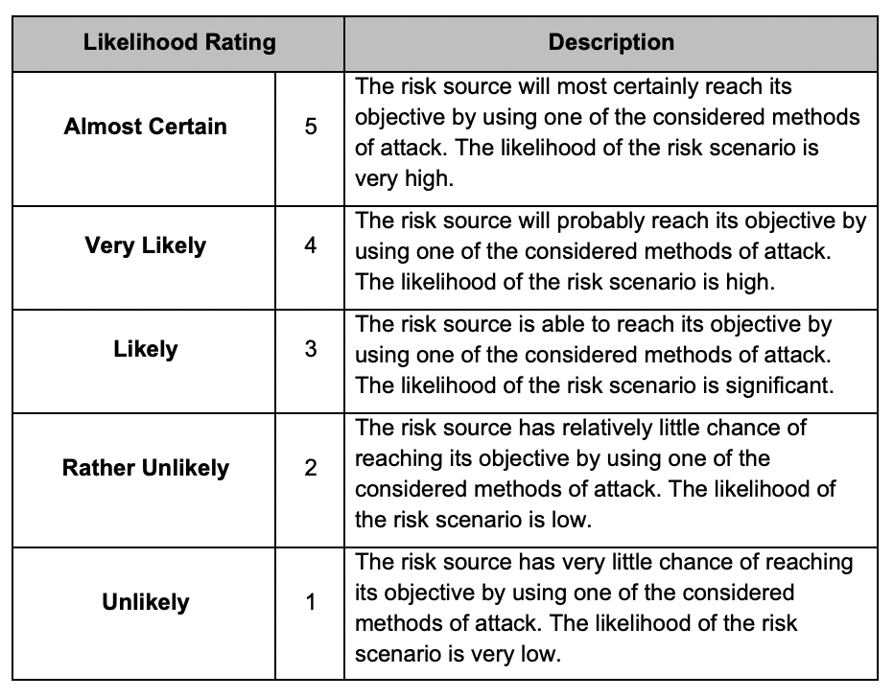
 | Impact Criteria
 | 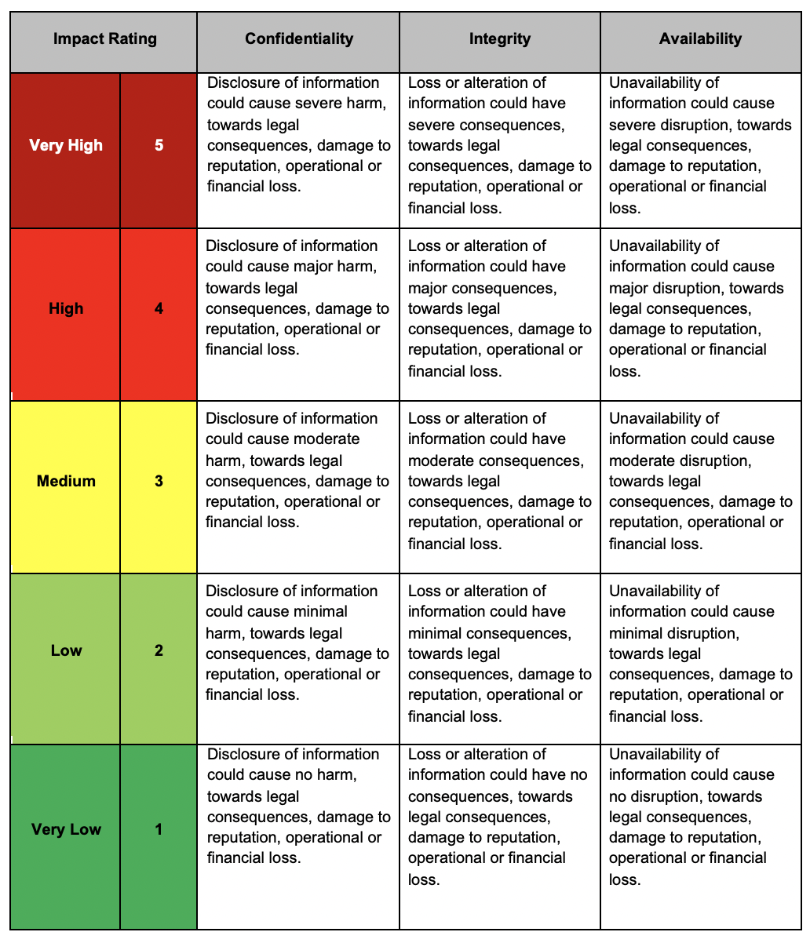
 | Risk Matrix
 | 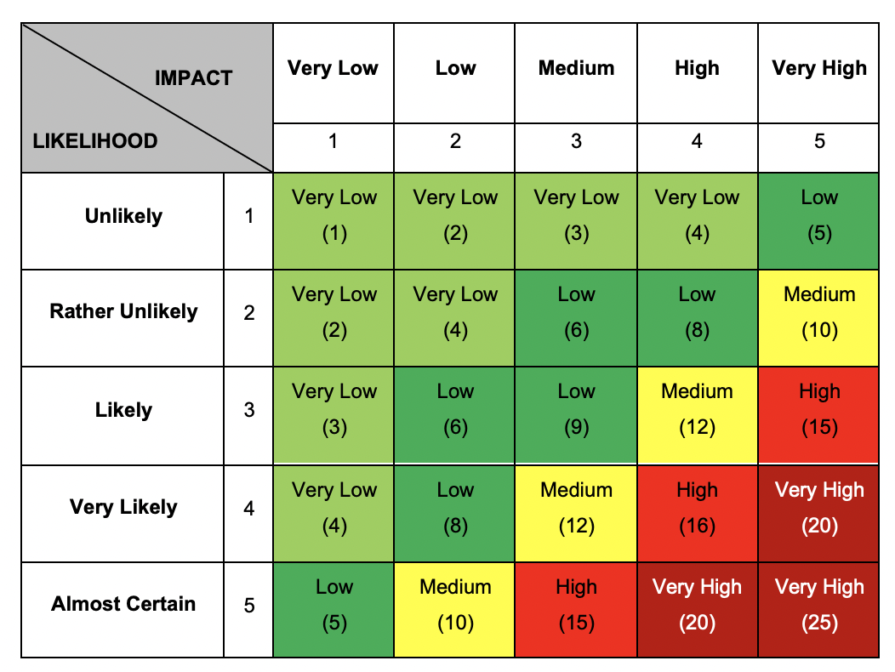

4. Cyber Security Risk Description

Requirement No. | 2 | References | Arahan Ketua Eksekutif No.5 – Subsection 9.2
Requirement | Cyber Security Risk Description
Detail Report | Risk Statement No 1 :
A concise sentence that summarises the risk, combining threat, vulnerability, and potential impact.
It should be written in a way that is understandable to both technical and non-technical stakeholders.

Example:
Unauthorised access to the financial system due to weak authentication controls could result in data breaches.

 | Asset:
 | Financial data
 | Risk (Threat) Description:
A short narrative describing the nature of the threat and how it could materialize.
Focus on who/what the threat is, how it could exploit a weakness, and the possible scenario.
Example:
Malicious outsiders or insiders attempt to exploit inadequate authentication measures to gain unauthorised access to sensitive financial data.

 | Cause (Vulnerability)
Identifies the underlying weakness or condition that allows the threat to be realized.
Example:
Lack of multi-factor authentication (MFA)

 | Consequences (Impact)
Explains the effect if the risk materialises, considering confidentiality, integrity, and availability (CIA triad). This should link to organisational consequences such as financial loss, reputational damage, operational disruption, or legal/regulatory penalties.
Example:
Exposure of confidential financial data.

 | Risk Statement No 2 :
Example:
System downtime due to ransomware attack may disrupt service delivery.
 | Assets
 | NPH System
 | Risk (Threat) Description:
Example:
A ransomware attack could render the system inoperable, preventing users from accessing essential services.

 | Cause (Vulnerability)
Example:
Outdated patch management.
 | Consequences (Impact)
Example:
Extended service disruption, financial losses due to operational delays, and erosion of public trust in the organization’s ability to deliver services reliably.

Notes: Please list all assets and risks relevant to the NCII.

5. Impact & Likelihood

Requirement No. |  |  | 3 |  |  | References |  | Arahan Ketua Eksekutif No.5 – Subsection 9.3
Requirement |  |  | Impact & Likelihood
Detail Report
Asset Name | Threat Name | Vulnerability Name | Impact |  |  |  | Impact Rating |  | Likelihood | Level of Risk
 |  |  | C | I | A
Financial data | Malicious outsiders or insiders attempt to exploit inadequate authentication measures | Lack of multi-factor authentication (MFA) | H | H | H |  | Very High |  | Rather Unlikely | Medium
NPH System | Ransomware Attack | Outdated patch management | H | H | H |  | Very High |  | Likely | High
6. Risk Prioritisation & Risk Treatment

Requirement No. |  |  |  | 4 |  |  | References |  | Arahan Ketua Eksekutif No.5 – Subsection 9.4
Requirement |  |  |  | Risk Prioritisation & Risk Treatment
 | Detail Report
Asset Name |  | Threat Name | Level of Risk | Risk Treatment Option | Control Reference Category | Control Reference / Treatment Activity |  | Timeline | Expected Treatment Impact | Expected Treatment Likelihood | Residual Risk
NPH System |  | Ransomware Attack | High | Modification | Technological Controls | A.8.8 Management of technical vulnerabilities  Establish a formal patch management program with defined timelines for applying security updates |  | 0–3 months | Very High | Rather Unlikely | Medium
Financial data |  | Malicious outsiders or insiders attempt to exploit inadequate authentication measures | Medium | Modification | Technological Controls | A.8.18 Secure log-on procedures  - Implement Multi-Factor Authentication (MFA) for all financial system users |  | 0–3 months | Very High | Unlikely | Low

7. Document Approval

PREPARED BY
Signature

Name
Designation
Date

REVIEWED BY
Signature

Name
Designation
Date

APPROVED BY
Signature

Name
Designation
Date

